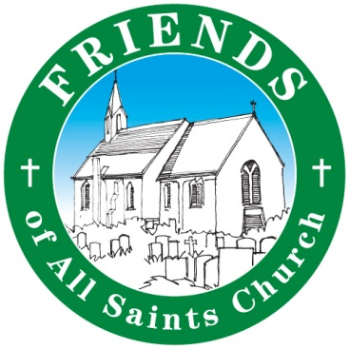
All Saints Church, West Parley

Churchyard Working Party
& Church Spring Clean
Saturday May 11th 9.30 – 12.30

Everyone Welcome!

If you can spare an hour or two please pop down and lend a hand to help keep our beautiful Saxon church looking its best. We will be clearing overgrown parts of the churchyard and spring cleaning in the church. Some tools and equipment will be provided but if you could bring some along too, that would be great.

Free refreshments for all hard-workers!

All Saints Church, Church Lane, West Parley BH22 8TR
For further info call Eve 01202 572611

