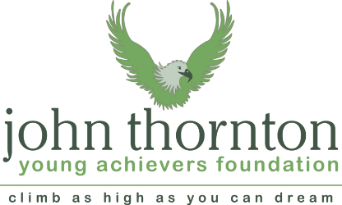
COMPANION DOG SHOW

Including “The Handler of the South”
ON
SATURDAY SEPTEMBER 24th 2016
AT

WEST PARLEY MEMORIAL HALL

NR HURN AIRPORT

IN AID OF THE JOHN THORNTON YOUNG ACHIEVERS FOUNDATION
& KINDLY SPONSORED BY WAGGING TAILS and OSCARS FOODS.
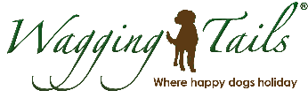

(KC PERMISSION)
Entries 9.30am Judging starts 11.00am
JUDGES: Sue Garner (Pedigree), Michelle Sherriff (Novelties),
Elise O’Connor (Handler of the South)
Rosettes to 5th and many trophies – Rosettes kindly sponsored by Margaret McWilliams

PEDIGREE CLASSES
DOGS NEED NOT BE REGISTERED WITH KENNEL CLUB
1. BABY AV PUPPY (4 to 6 months) 2. AV PUPPY (6 to 12months)
3. AV GUNDOG 4. AV TERRIER & HOUND
5. AV WORKING & PASTORAL 6. AV TOY & UTILITY
7. AV OPEN
BEST IN SHOW, RESERVE BEST IN SHOW & BEST PUPPY IN SHOW.

HANDLER of THE SOUTH – Back by popular demand.
8. 6 to 11 years.
- 12 to 16 years.
- 17 to 49 years.
- 50 and Over.

NOVELTIES
12. BEST CROSSBREED
13. PRETTIEST BITCH
14. HANDSOME DOG
15. WAGGIEST TAIL
16. BEST CONDITION DOG/BITCH
17. DOG THE JUDGE WOULD LIKE TO TAKE HOME
18. VETERAN over 7 years
19. BEST RESCUE
20. CONSOLATION CLASS (NOT HAVING WON A 1ST TODAY)
BEST NOVELTY IN SHOW

ENTRIES £1 Novelties & Handler classes. £1.50 Pedigree
NO CC OR RES CC OR JUNIOR WARRANT WINNERS
NO DOGS OFF LEAD - NO BITCHES IN SEASON
PROMOTER ACCEPTS NO RESPONSIBILITY FOR ANY DAMAGE HOWSOEVER CAUSED.
PARKING £1 (COST OF FIELD) LIMITED DISABLED PARKING BEFORE 10.00am OR TELEPHONE AS BELOW
STALLS WELCOME £5 PER PITCH – NO WET WEATHER COVER

Any queries please call NICKY SMITH - 01202 486239 or PAM RUTLEY - 01202 673017

